WSN Practical

**Practical 4**

**what is Omnett++?**

OMNeT++ is a discrete event simulation framework. It's primarily used for modeling and simulating complex systems in the domains of computer networks (like wired, wireless, and mobile ad hoc networks), vehicular networks, and other distributed systems. The name stands for "Objective Modular Network Testbed in C++." It provides a component-based and modular architecture, allowing developers to create simulations by assembling reusable simulation models. OMNeT++ also offers a rich set of libraries, tools, and APIs for simulation development and analysis. It's widely used in both academic research and industrial applications for evaluating new protocols, algorithms, and architectures in networking and distributed systems.

**AdHoc network**

An ad hoc network is a type of wireless network where devices communicate directly with each other without the need for a centralized infrastructure, such as routers or access points. In ad hoc networks, devices dynamically form connections with nearby devices to establish communication links, creating a temporary network. This enables communication in situations where infrastructure-based networks are impractical, such as in disaster recovery operations, military operations, or spontaneous gatherings.

Ad hoc networks can be classified into two main types:

1. **Mobile Ad Hoc Networks (MANETs)**: In MANETs, the participating devices are typically mobile, such as laptops, smartphones, or vehicles. These devices can move freely, and the network topology changes dynamically as devices move in and out of range of each other.

2. **Vehicular Ad Hoc Networks (VANETs)**: VANETs are a specific type of MANETs where the participating devices are vehicles equipped with wireless communication capabilities. VANETs are primarily used for communication among vehicles (V2V communication) and between vehicles and roadside infrastructure (V2I communication) for applications such as traffic management, road safety, and infotainment.

Ad hoc networks present unique challenges due to their dynamic and self-organizing nature, such as routing in the absence of fixed infrastructure, network security, resource management, and scalability. Researchers often use simulation tools like OMNeT++ to model and analyze the performance of ad hoc network protocols and algorithms under various conditions.

**Practical 5**

Aim : Understanding, Reading and Analyzing Routing Table of a network

First we will create router topology , take 5 routers(1841) & connect this router

1st router (fast ethernet(0/0) with fastethernet(o/1) 2nd router

Router 2 to router 3 (0/1)

Router 3rd to 4th fastethernet(0/0)

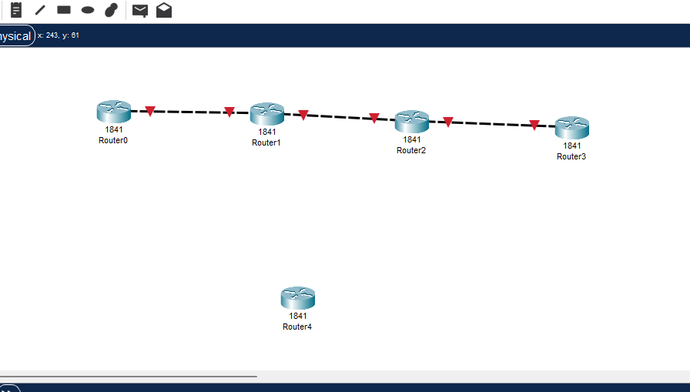

Take 2nd router and turnoff the switch

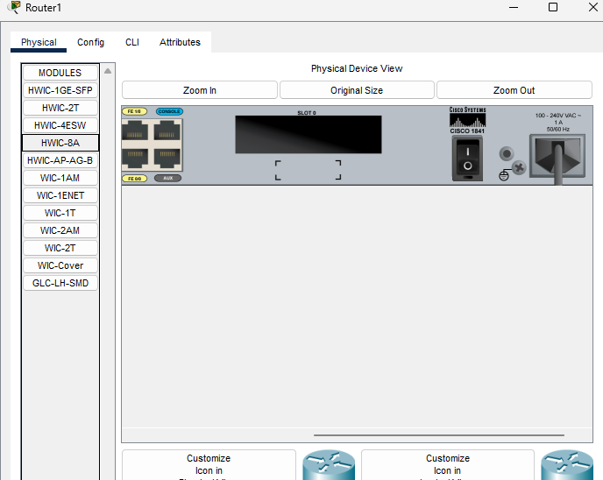

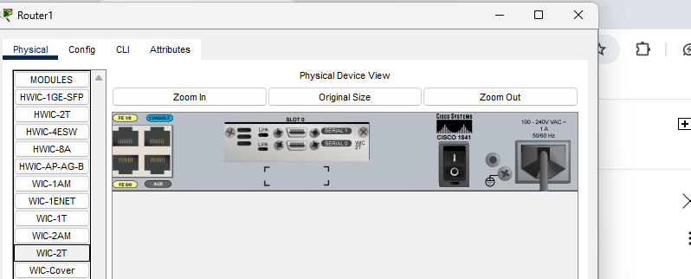

And switch on

Do the same thing with router 4

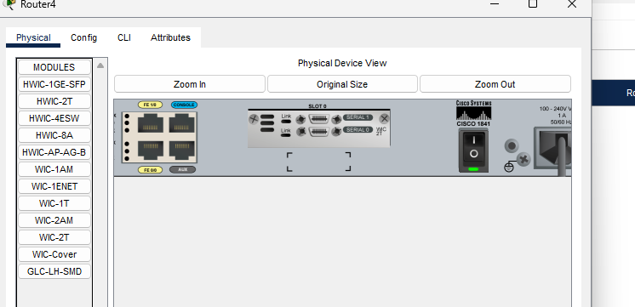

Connect router 2 with serial cable (serial 0/0/1) with router 4

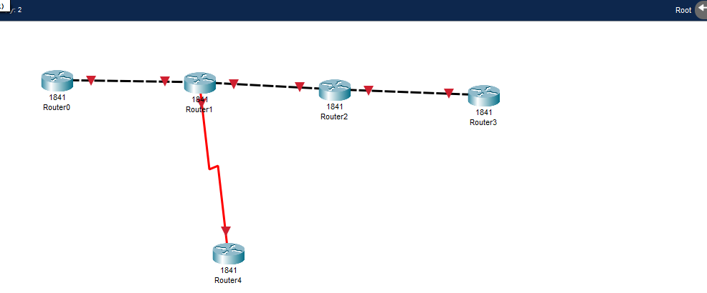

Give the IP addresses to the each router

Router 0

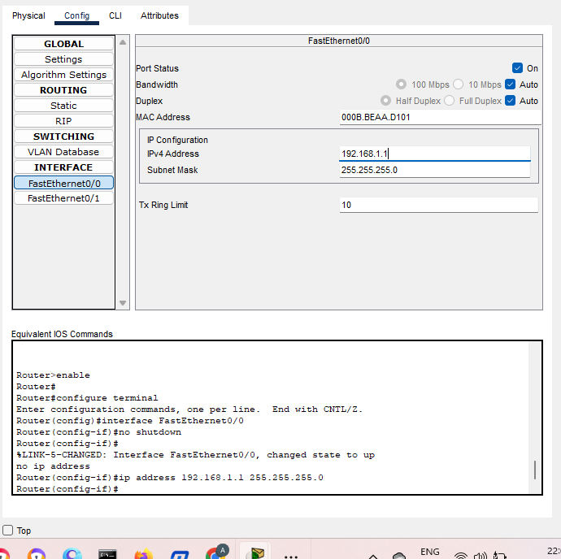

Router 1 has 2 interfaces

First fast ethernet 2nd serial

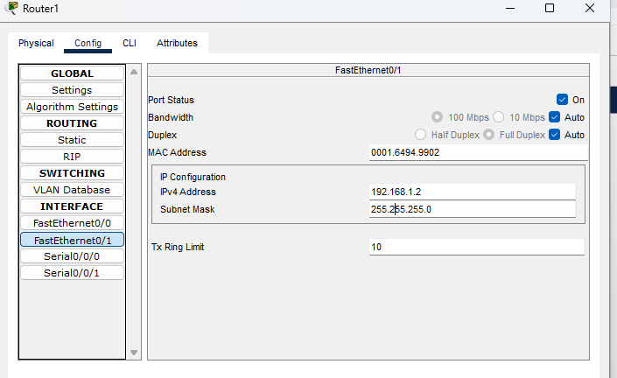

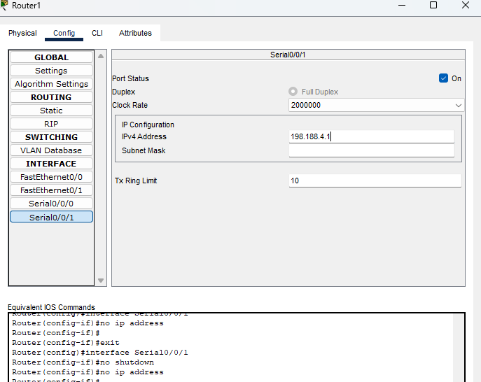

Router 2

Has 2 configure interfaces fastethernet 01 and fE 00

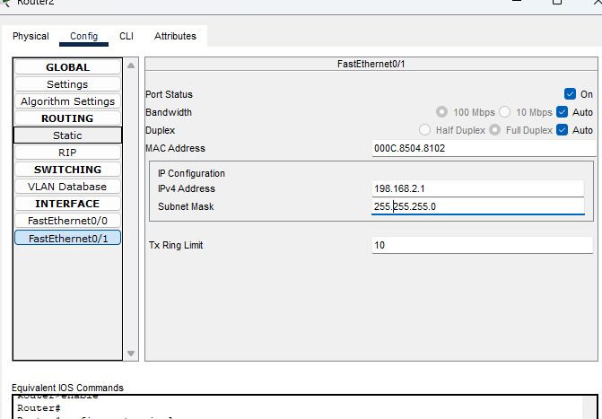

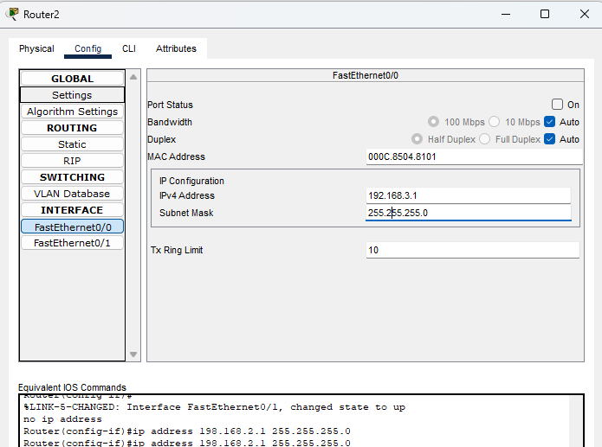

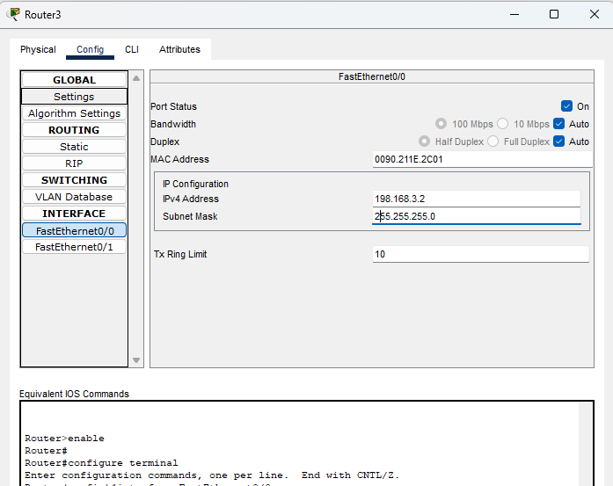

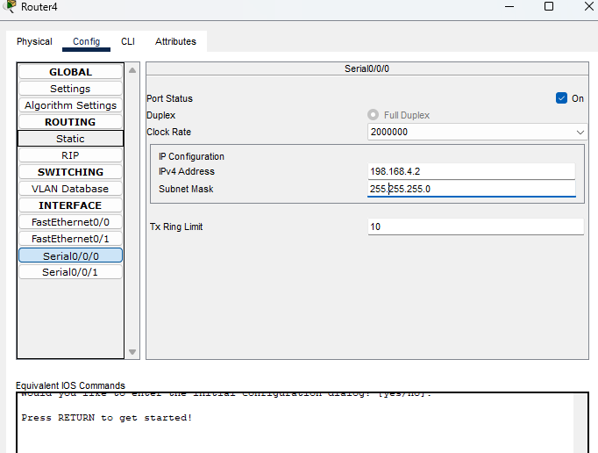

Add network to each router we used here RIP protocol

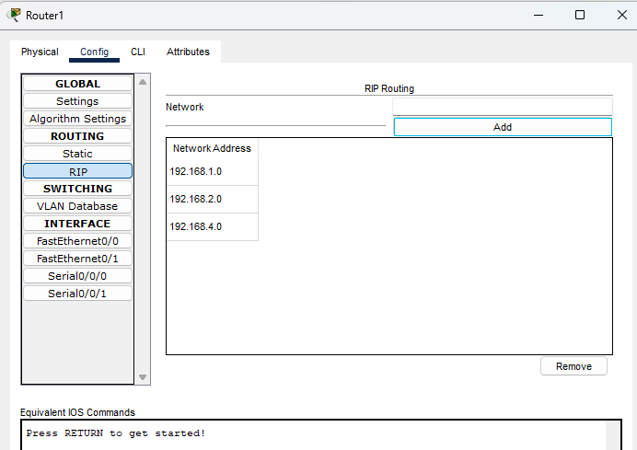

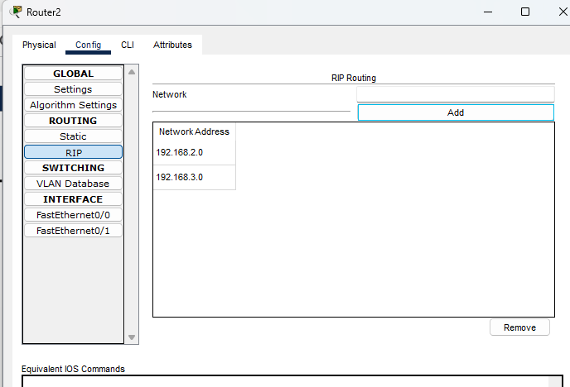

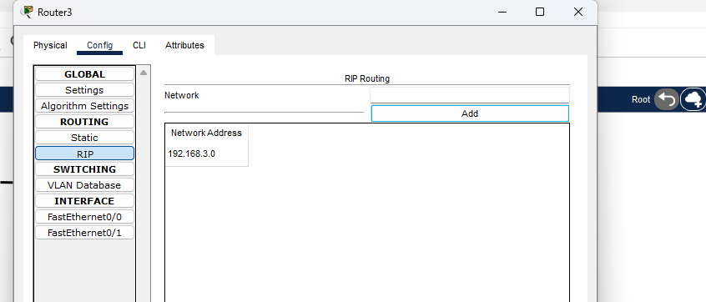

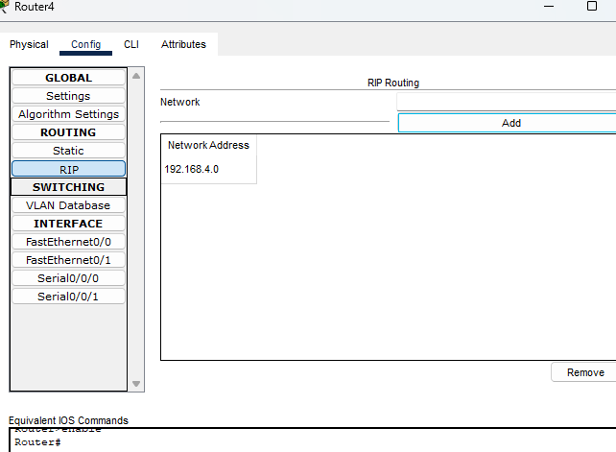

To check the routing path we need to router 1 type the following command in CLI mode

Select routr 1

Exit command 2 time

And then show ip route command

Then it will show ip addresses

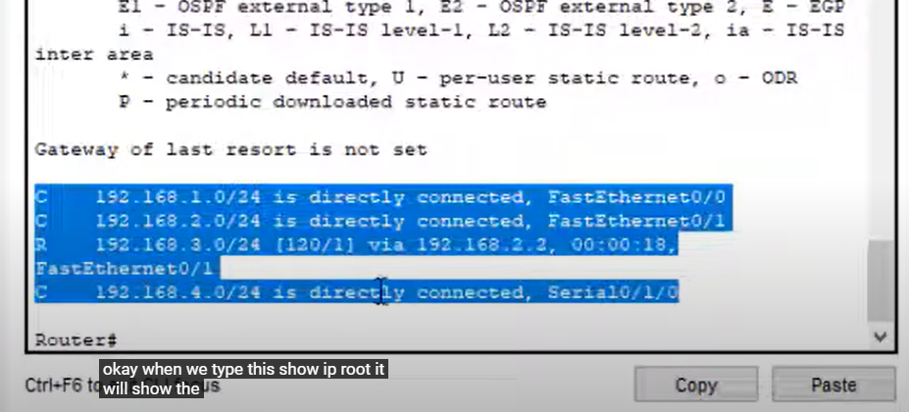

**Practical 6**